WASABI / HumanEnerDIA / OVOS-EnMS

Final System Documentation

Version | 1.0
Date | 2026-06-08
Status | Final delivery documentation package
Purpose | Provide a stakeholder-ready end-to-end overview, installation/operation guide, workflows, and final delivery notes.
Intended audience | Managers, reviewers, operators, users, integrators, and external WASABI partners.

Evidence rule: This document summarizes the evidence-backed content of the technical documents and points readers to implemented local sources.

Table of Contents
1. Project Overview
2. Installation And Access
3. Main Workflows
4. Operator Guide
5. Analytics, Dashboards, Reports, And Assistants
6. Maintenance And Troubleshooting
7. Final Delivery Notes
8. Limitations And Assumptions
9. Evidence References

Project Overview
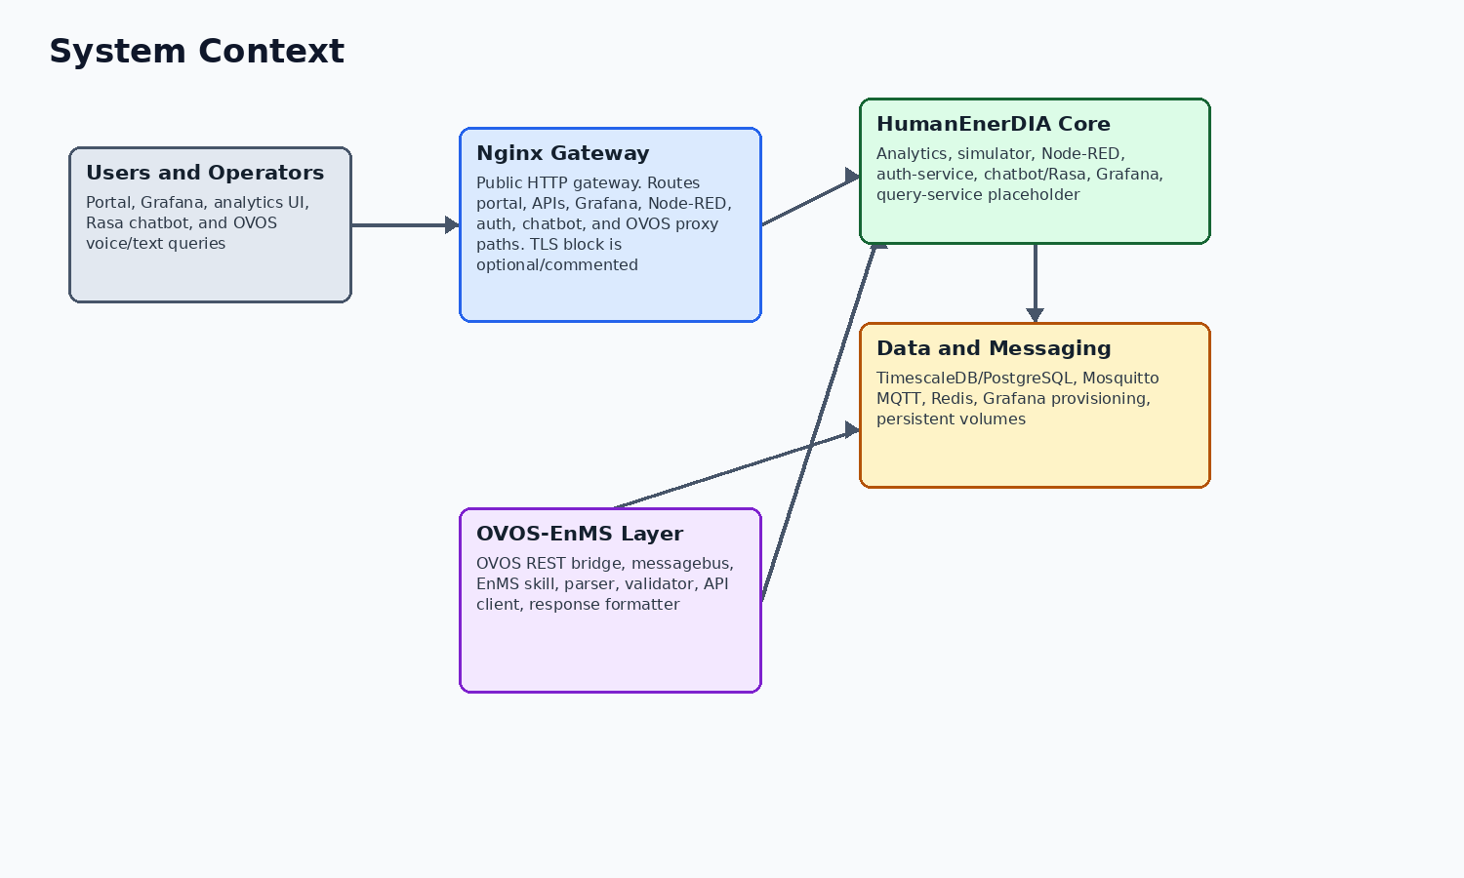
Figure 1. Relationship between HumanEnerDIA, OVOS-EnMS, data services, dashboards, and users.
HumanEnerDIA is an open-source industrial energy management system developed for the WASABI project delivery context. It monitors and analyzes simulated or ingested factory energy data, provides dashboards and APIs, supports ISO 50001-oriented concepts, and integrates with an OVOS assistant layer for natural-language operational queries.
The final package should be described as a Docker Compose deployable system with a companion OVOS-EnMS assistant. It includes implemented backend services, dashboards, reports, simulator, ingestion flow, authentication, text chatbot, and OVOS voice/natural-language paths. It also includes documented limitations that must remain visible for review.

Installation And Access
For a local or evaluation deployment, use the guided setup script from the repository or extracted release bundle. For remote browser access, pass a server host or IP so generated URLs match the expected access path. Generated credentials are stored in .env and must be kept private.
Access point | Default URL | Notes
Unified portal | http://<host>:8080 | Served by Nginx from portal/public
Grafana | http://<host>:8080/grafana | Sub-path proxy to Grafana with provisioned dashboards
Analytics UI | http://<host>:8080/analytics/ui/ | FastAPI-rendered analytics templates
Analytics API docs | http://<host>:8080/api/analytics/docs | Nginx proxy to analytics OpenAPI docs
Simulator docs | http://<host>:8080/api/simulator/docs | Nginx proxy to simulator OpenAPI docs
Node-RED | http://<host>:1881 or http://<host>:8080/nodered/ | Admin UI protected by Node-RED credentials
OVOS bridge | http://<host>:5000/health | Available when OVOS stack/overlay is deployed

Main Workflows
Workflow | Implementation path | Result
Start system | ./setup.sh or docker compose build/up | Services start with generated or configured environment values.
Generate telemetry | simulator -> MQTT -> Node-RED -> PostgreSQL | Energy, production, environmental, status, and selected multi-energy data are stored.
View dashboards | Grafana through Nginx or direct port | Configured SOTA dashboard JSON views are available.
Use analytics APIs | FastAPI analytics service under /api/v1 | KPIs, baselines, forecasts, anomalies, reports, and related data are exposed.
Authenticate/admin | auth-service through portal and /api/auth, /api/admin | Registration/login/admin/session flows use JWT and database tables.
Ask text help questions | chatbot Express proxy -> Rasa -> custom action QA retrieval | Knowledge/help answers from qa_data.json categories.
Ask operational assistant questions | OVOS REST bridge -> messagebus -> EnMS skill -> analytics API | Voice/text operational responses with structured data.
Generate reports | analytics report endpoints | Legacy monthly EnPI PDF and V2 PDF paths are available.

Operator Guide
- Use docker compose ps and service health endpoints for daily status checks.
- Check Nginx first for browser routing issues, then the owning upstream service.
- Inspect simulator, MQTT, Node-RED, and PostgreSQL together for data-ingestion issues.
- Use scripts/backup-grafana-dashboards.sh for tracked Grafana dashboard JSON backups.
- Use pg_dump or platform backup tooling for PostgreSQL; no generic tracked database backup script exists.
- Avoid docker compose down -v unless the purpose is deliberate persistent data deletion.

Analytics, Dashboards, Reports, And Assistants
Analytics capabilities include baseline training/prediction/deviation, KPI functions, forecasting, anomaly detection/search, machine status and time series, comparison/visualization data, model performance, production metrics, performance analysis, ISO 50001/SEU endpoints, and report generation.
Dashboards are configured in Grafana JSON and provisioned through the Grafana provisioning directory. The Rasa chatbot is a text help/knowledge assistant, while OVOS-EnMS is the operational natural-language assistant integrated with live backend APIs.
Dashboard or assistant | Purpose
Grafana dashboards | Operational, executive, cost, carbon, ISO 50001, anomaly, model, production, and predictive views.
Analytics UI | FastAPI-rendered pages for dashboards, baselines, anomalies, KPIs, forecasts, Sankey, heatmap, comparison, and model performance.
Rasa chatbot | Text knowledge/help assistant using QA categories and custom retrieval action.
OVOS-EnMS | Operational assistant for energy, power, machine status, rankings, anomalies, forecasts, baselines, KPIs, reports, help, and health checks.

Maintenance And Troubleshooting
Maintenance should focus on credential rotation, backup verification, dashboard export/commit policy, disk usage, restart counts, recent errors, image/base dependency review, and firewall/public route review. Production hardening requires operator policy beyond the repository defaults.
Maintenance area | Recommended review
Credentials | Rotate generated first-run values and any exposed credentials.
Backups | Test PostgreSQL restore; back up Grafana dashboards and Docker volumes.
Dashboards | Commit intended Grafana JSON changes after backup/export.
Telemetry | Confirm simulator/MQTT/Node-RED/PostgreSQL are all healthy when data appears stale.
OVOS | Confirm /health messagebus_connected and smoke query when assistant is required.
Docs | Update final documents when route, schema, compose, or packaging behavior changes.

Final Delivery Notes
- Product 1 is the OVOS skill artifact; Product 2 is the full-stack HumanEnerDIA artifact according to docs/DELIVERY_READINESS.md.
- SHA256 checksums are expected for release artifacts.
- .env is not shipped and must not be disclosed.
- The optional Qwen GGUF model is not bundled in the main release artifacts according to delivery readiness notes.
- query-service is intentionally excluded from release readiness expectations.
- Runtime health must be verified on the actual target deployment before stakeholder demonstration or handover.

Limitations And Assumptions
The following items should be reviewed before stakeholder distribution. They are documented to avoid overstating the current implementation.
Item | Status
query-service | Placeholder only; Docker service exists, healthcheck disabled, and it is excluded from release readiness expectations.
Runtime verification | This documentation package records compose validation. Live health checks require a running deployment and are not implied unless run separately.
OVOS release artifact | The OVOS source tree may contain local GGUF model files, but release notes state optional GGUF weights are not bundled by default.
Third-party EnMS support | OVOS portability is through a HumanEnerDIA-compatible API or adapter/proxy, not zero-code support for arbitrary vendor APIs.
Reports V2 | V2 report code is implemented, but some service calculations use derived/proportional or placeholder values; final stakeholders should review report semantics before audit use.
Simulator inventory | The simulator code supports boiler in addition to compressor, HVAC, motor, pump, and injection molding. One simulator info response still lists five machine types.
Security posture | The codebase provides secret placeholders, generated first-run credentials, JWT/bcrypt auth, health checks, and hardening guidance. Public production exposure still requires operator DNS/TLS/firewall/credential work.

Evidence References
The table below lists the main local evidence used for this document. It is not a full file inventory; it identifies the sources behind the material claims.
Topic | Evidence
Overview/docs | README.md; docs/README.md; docs/TECHNICAL_ARCHITECTURE_GUIDE.md; docs/OPERATIONS_RUNBOOK.md
Deployment | docker-compose.yml; setup.sh; scripts/verify-wasabi-release.sh
Analytics/database | analytics/main.py; database/init/02-schema.sql; database/init/03-timescaledb-setup.sql; database/init/04-functions.sql
Dashboards and reports | grafana/provisioning/; grafana/dashboards/; analytics/api/routes/reports.py; analytics/reports/; analytics/reports_v2/
OVOS-EnMS | /home/ubuntu/ovos-llm/README.md; /home/ubuntu/ovos-llm/enms-ovos-skill/README.md; /home/ubuntu/ovos-llm/enms-ovos-skill/bridge/ovos_rest_bridge.py; /home/ubuntu/ovos-llm/enms-ovos-skill/enms_ovos_skill/__init__.py
Delivery readiness | docs/DELIVERY_READINESS.md; releases/HumanEnerDIA-full-stack-v1.0.0-release-notes.md

